CSA1519-CLOUD COMPUTING LAB EXERCISES
Jayaharini.J(192371034)
EXP-1 : Flight Reservation System
Aim
To create a simple Flight Reservation System using Zoho Creator, a cloud-based SaaS platform, for managing flight bookings, passenger details, and reservation information.
Procedure
- Log in to Zoho Creator.
- Create a new application named Flight Reservation System.
- Create a form named Flight Reservation.
- Add the required fields such as Passenger Name, Email, Phone Number, Flight Number, Source, Destination, Travel Date, Number of Tickets, Ticket Price, and Total Fare.
- Create a workflow to automatically calculate the Total Fare based on the number of tickets and ticket price.
- Create reports to display all reservations and booking details.
- Save and publish the application.
- Test the application by entering sample reservation details and verify that the total fare is calculated correctly.

Output :
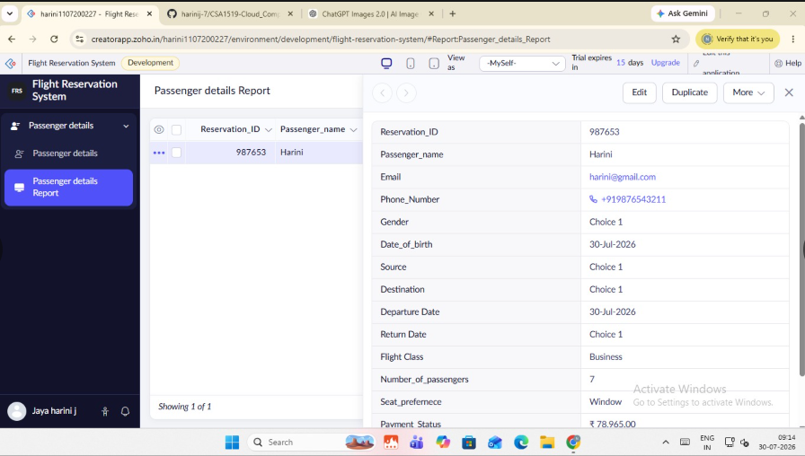

Result
The Flight Reservation System was successfully created using Zoho Creator, enabling users to book flights, manage reservation details, and automatically calculate the total fare through a cloud-based SaaS application.

